Stages in language analysis
Adapted from a chart by John Irons
Structure  (coherence) | 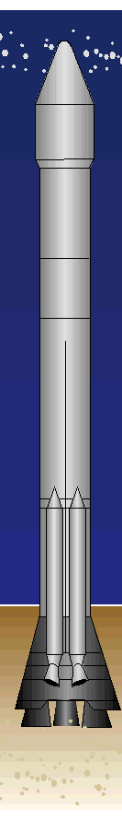 | Content  – the controlling idea
Syntax  (cohesion) |  | expressed through the use of  1) sentence elements (SVOCA) – rules for function and position
Morphology  (the study of structure and form of words) |  | and  2) word classes defined through their form
Spelling |  | etymology / pronunciation
Phonemics  (the study of the smallest units of sound capable of changing the meaning of a word. Phonemes = fx. h in hat, s in sat) |  | The oral expression

